1.MDI FORM [WELCOME SCEEN]:-

2. FORM 1 START:-

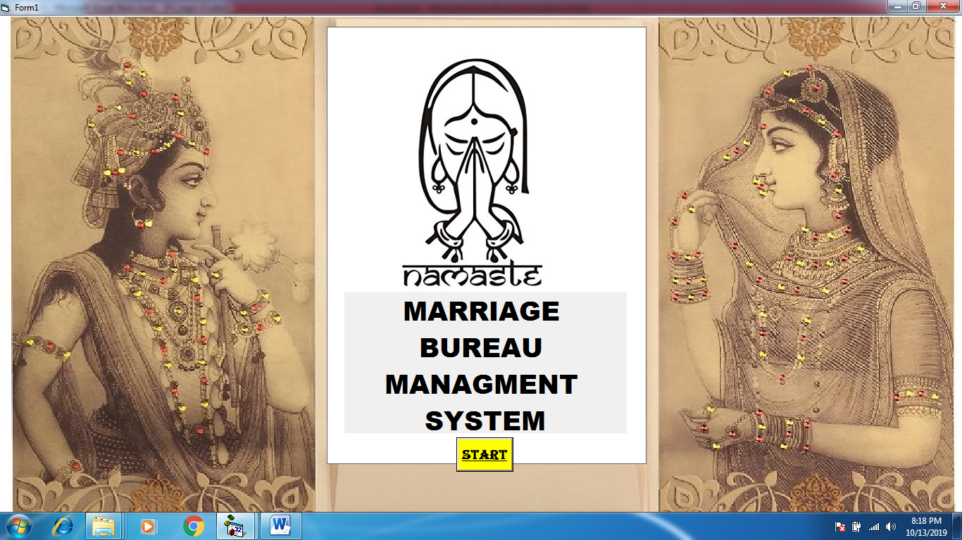

2.1 PROGRESSBAR:-

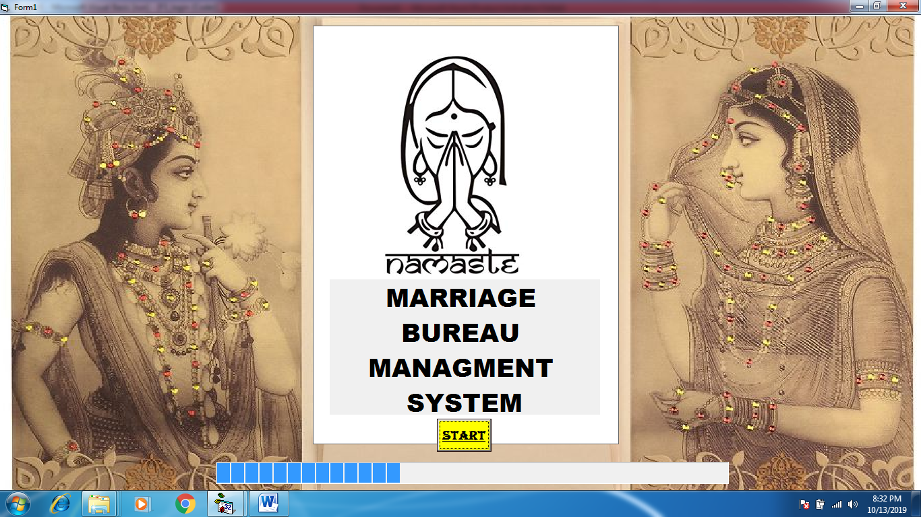

2.2 MESSAGE BOX:-

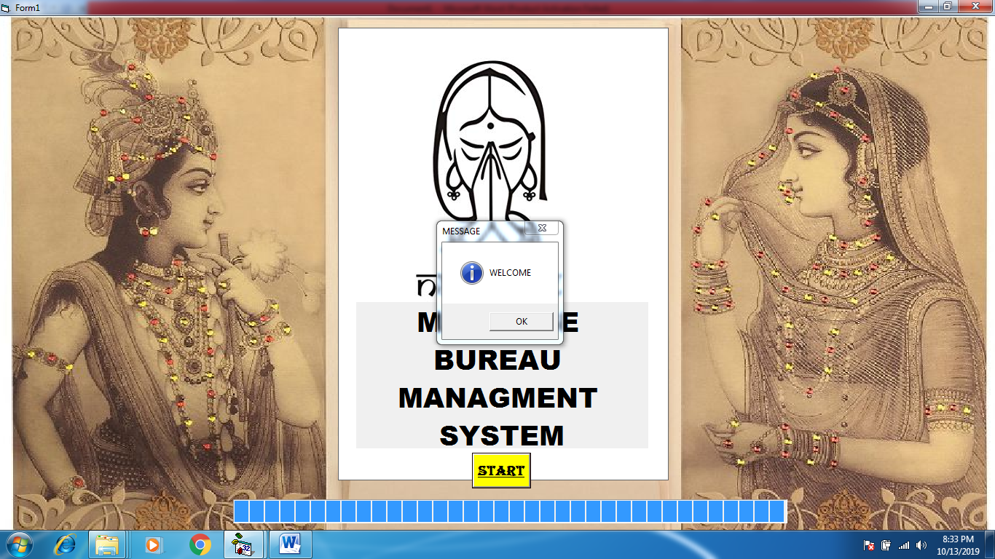

3. FORM 2 DESCRIPTIONS

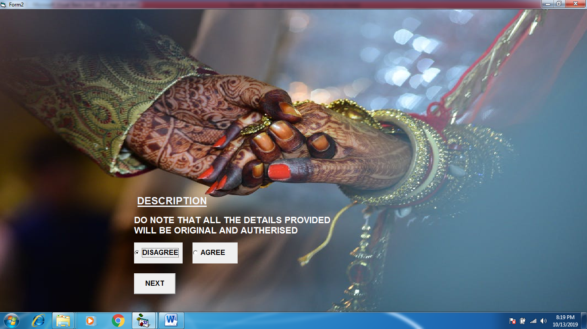

3.1 OPTION “AGREE” WHEN SELECTED:-

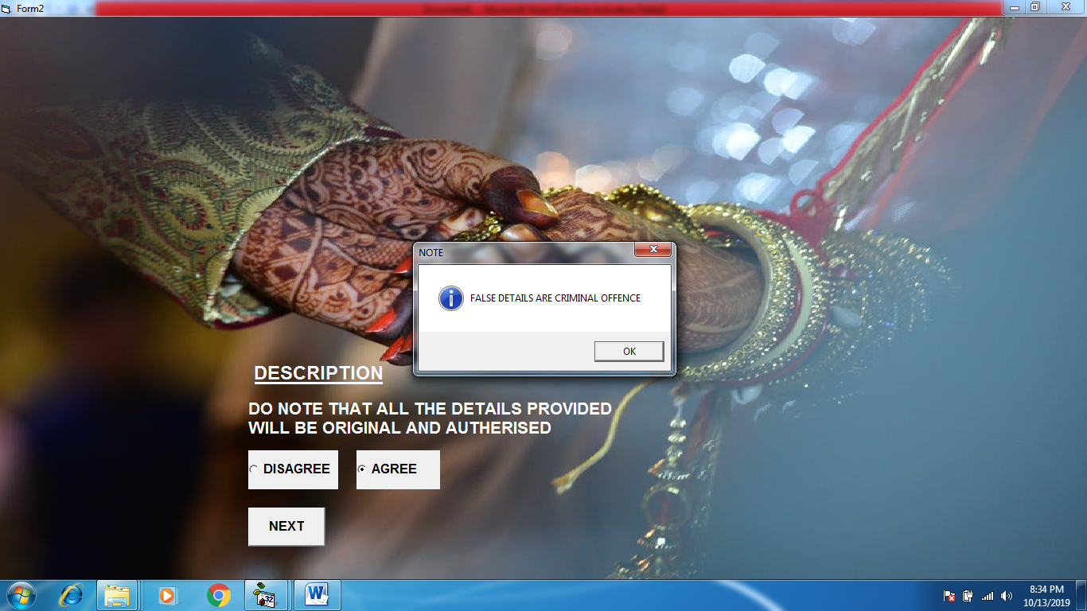

4. FORM 3 LOGIN

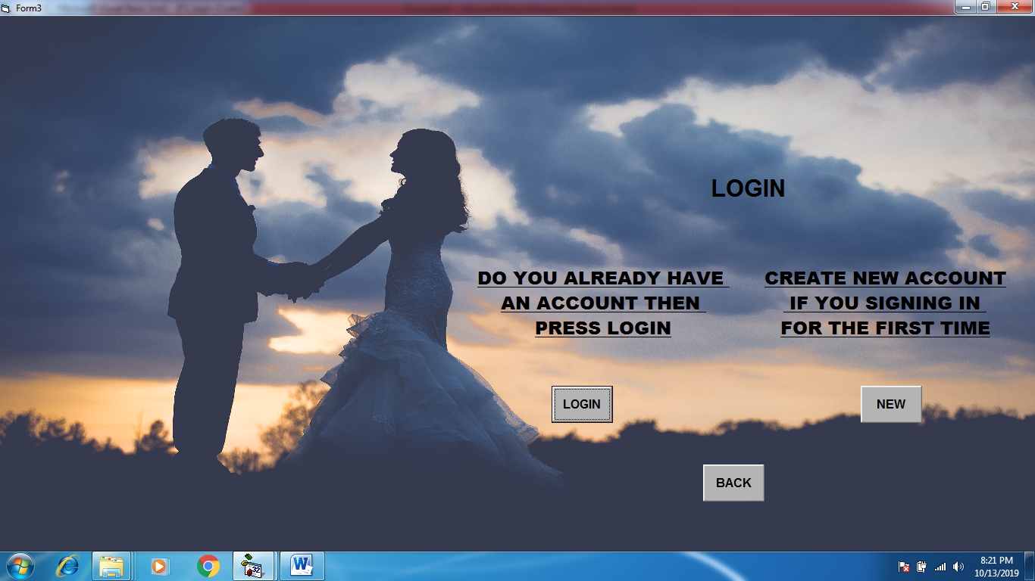

5. FORM 4 ALREADY ACCOUNT:-

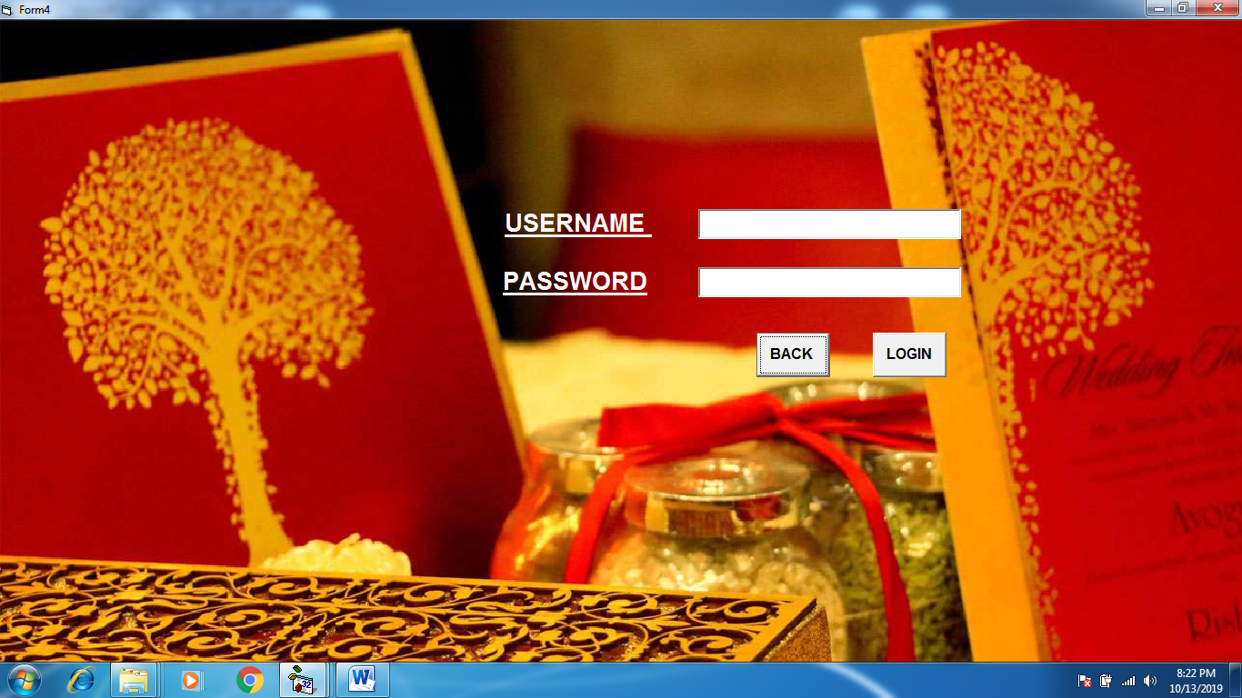

5.1 WHEN INCORRECT PASSWORD :-

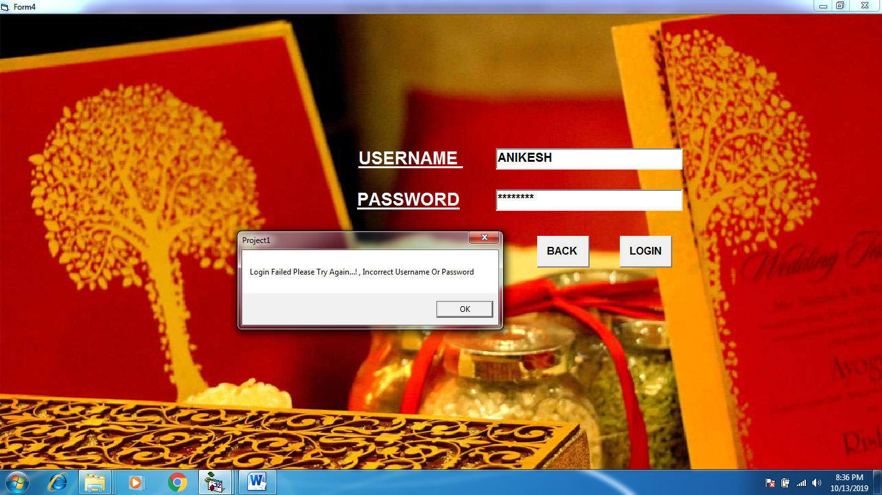

6. FORM 5 CREATES NEW ACCOUNT:-



6.1 WHEN PASSWORD AND COFIRM PASSWORD DOESN’T MATCHES:-

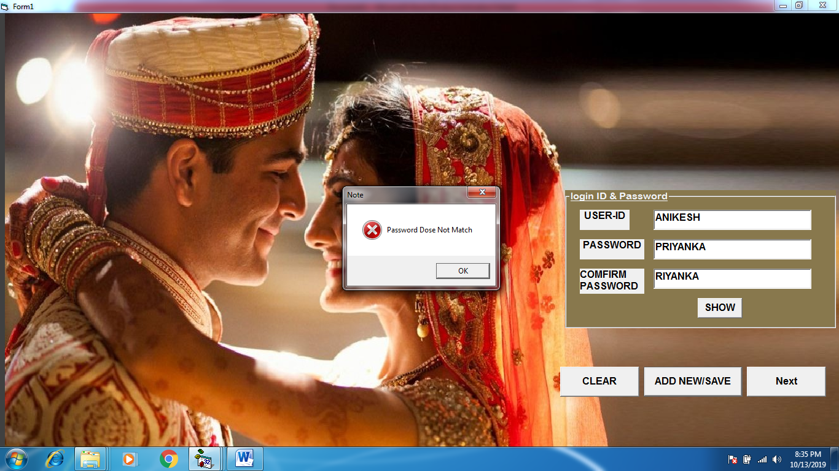

6.2 WHEN ID AND PASSWORD IS CORRECT:-

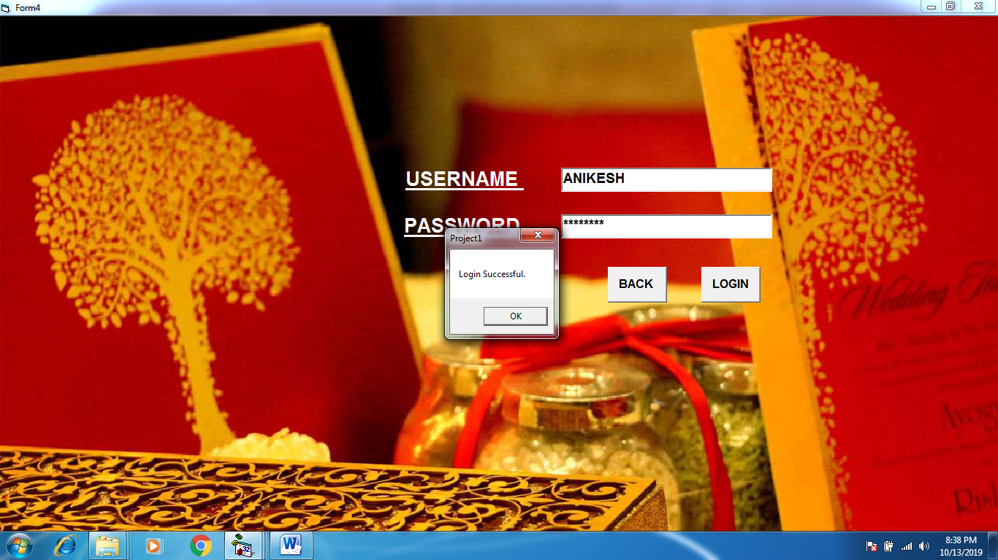

7. FORM 6 PERSONAL INFORMATION:-

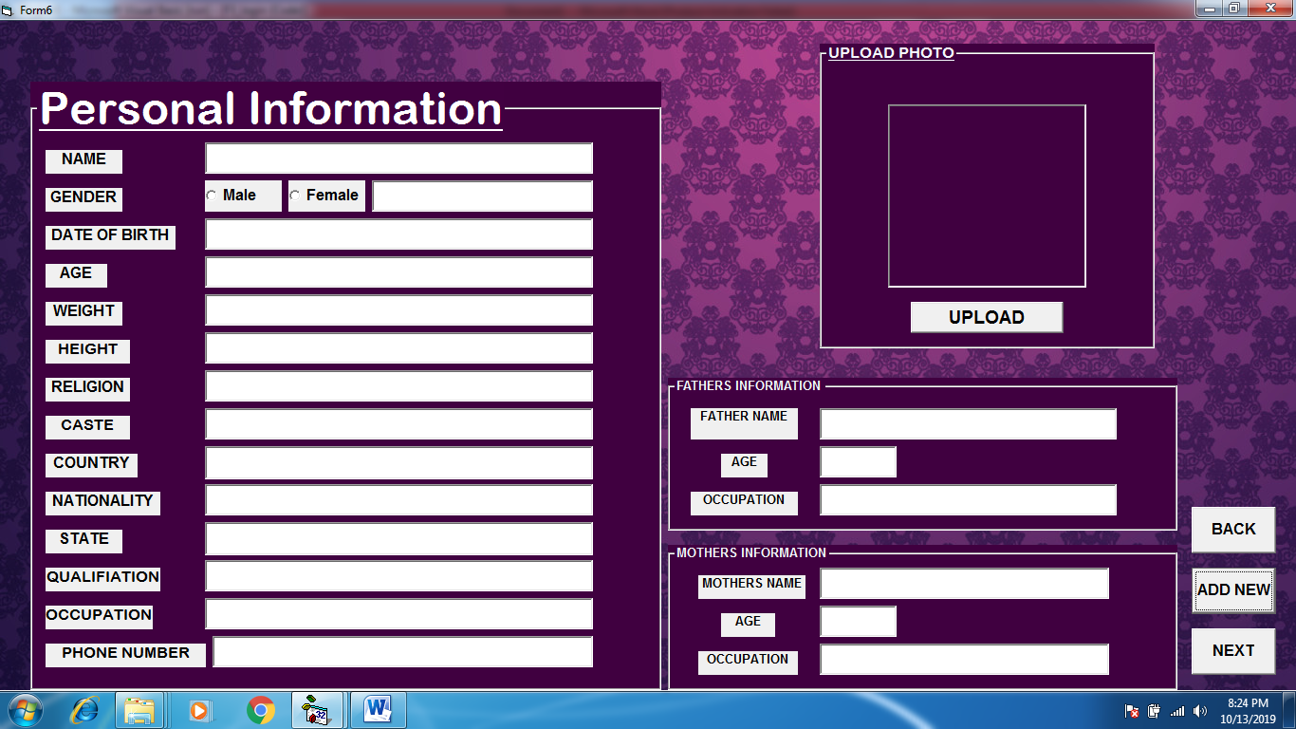

8. FORM 7 DETAILS:-

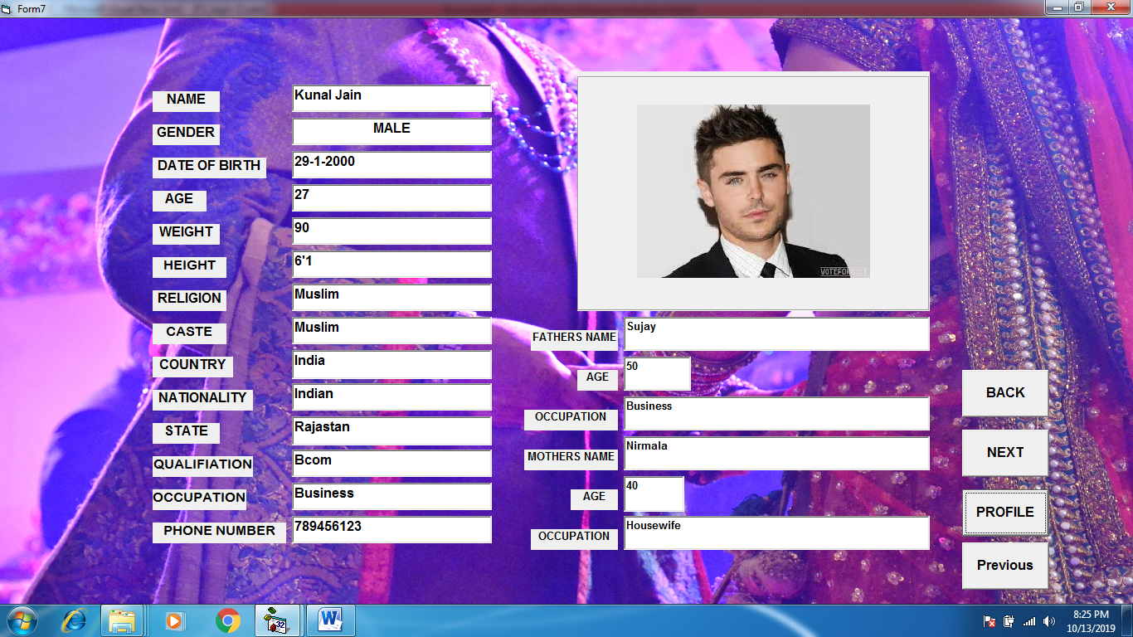

9. FORM 8 SEARCH:-

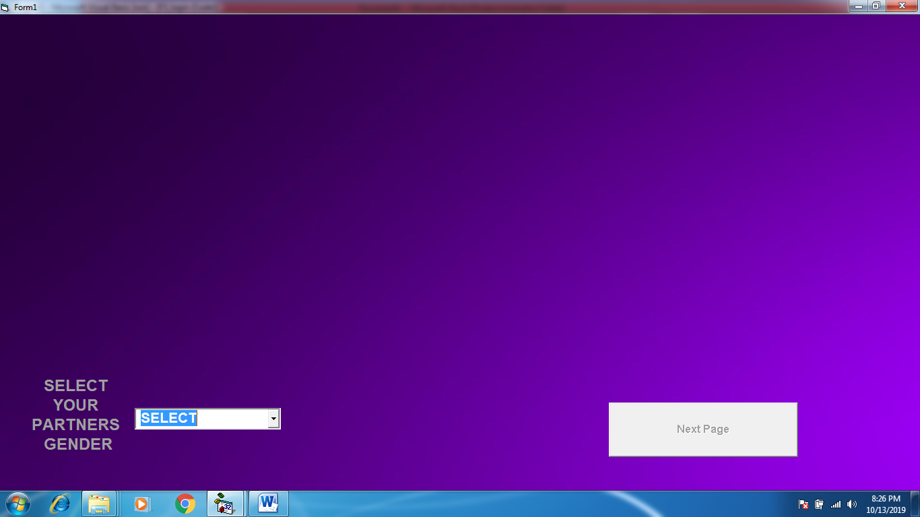

9.1 IF OPTION MALE SELECTED:-

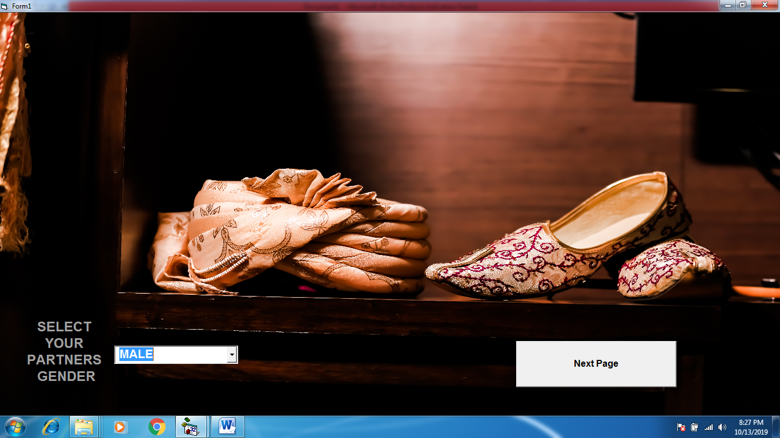

9.2 IF OPTION FEMALE SELECTED:-

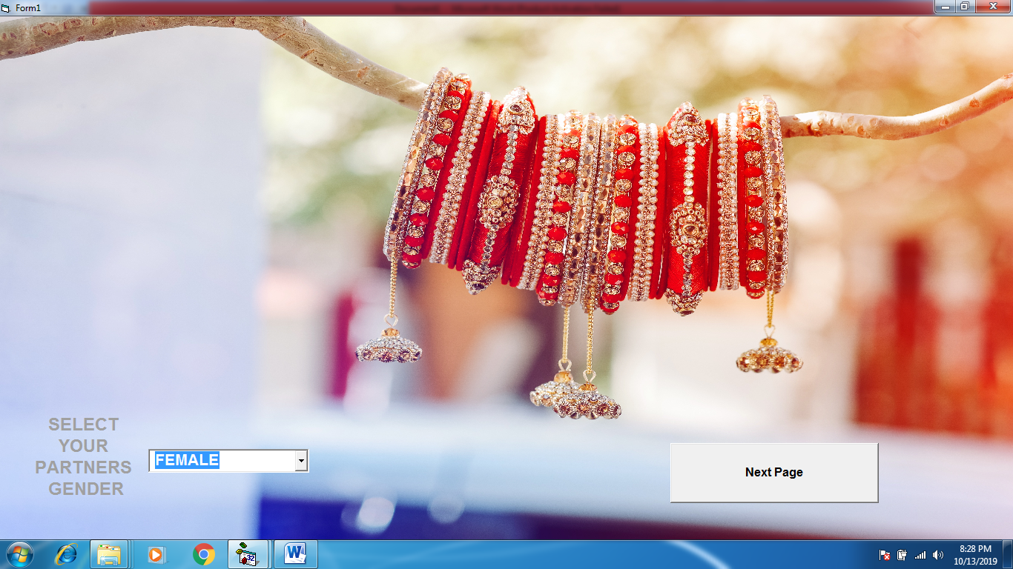

10.RESULTS FORM:-



10.1 FOR MALE DATA :-

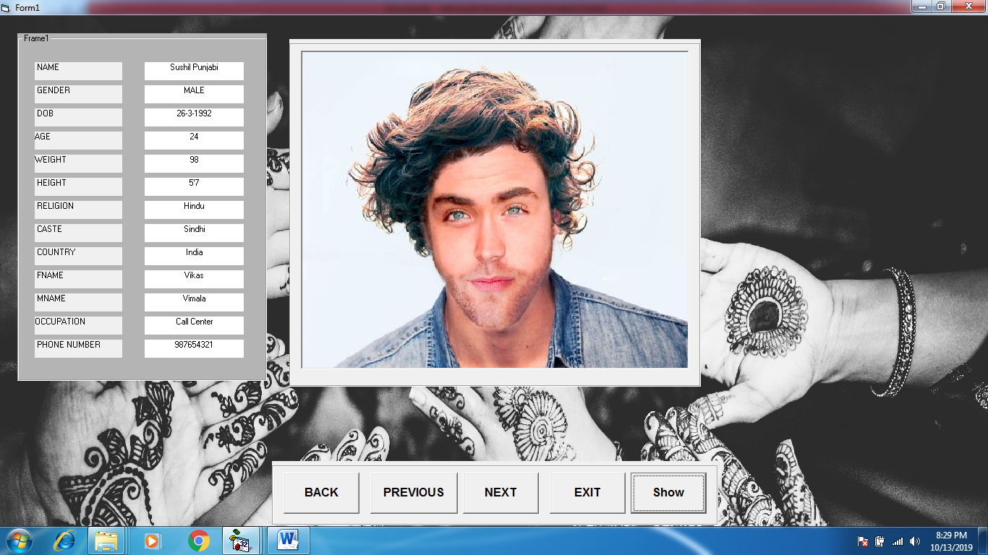

10.2 FOR FEMALE DATA:-

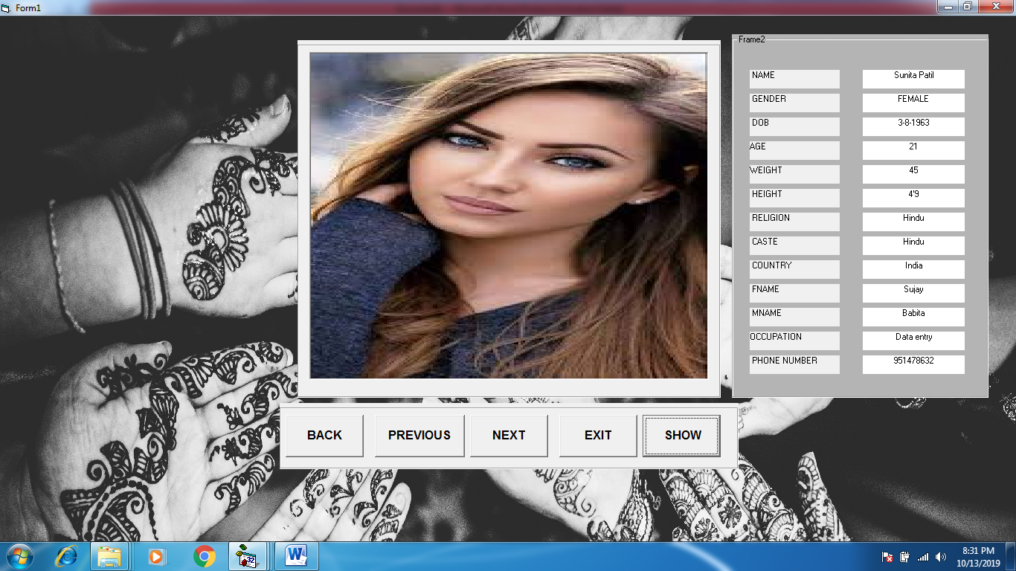

11. FORM THANK YOU:-



12. MDI MENU – ABOUT US:-

